**Manufacturing Line Productivity Analysis Using Power BI Documentation**

**Project Overview**

**This project analyzes the productivity of a manufacturing line using Power BI. The objective is to gain insights into production efficiency and identify key downtime factors.**

**Project Scope**

**The scope of this project includes:**

* **Analyzing batch-level production data to assess productivity.**
* **Identifying downtime factors and their impact on production.**
* **Creating interactive Power BI visualizations to support data-driven decision-making.**

**Data Sources**

**The project uses the following data sources:**

* **Line Productivity: Batch-level production data with product type, operator, and time details.**
* **Products: List of products with descriptions and minimum batch times.**
* **Downtime Factors: Description of various downtime reasons and whether they are operator related.**
* **Line Downtime: A Detailed record of downtime occurrences per batch.**

|  |  |  |
| --- | --- | --- |
| **Table** | **Field** | **Description** |
| Line productivity |  | Fact table containing details for each batch produced |
| Line productivity | Date | Date the batch was produced **(Date).** |
| Line productivity | Product | ID for the product produced in the batch **(Text).** |
| Line productivity | Batch | Unique ID for the batch produced **(Whole Number).** |
| Line productivity | Operator | Production line operator in charge of the batch **(Text).** |
| Line productivity | Start Time | Time the batch production started **(Date/Time).** |
| Line productivity | End Time | Time the batch production ended **(Date/Time).** |
| Products |  | Dimension table with details on each product |
| Products | Product | Unique product ID **(Text).** |
| Products | Flavor | Soda flavor for the product **(Text).** |
| Products | Size | Product size (volume) **(Text).** |
| Products | Min batch time | Minimum time required to produce a batch (with no downtime) **(Whole Number).** |
| Line downtime |  | Fact table containing downtime (in minutes) by factor for each batch |
| Line downtime | Batch | Unique ID for the batch produced **(Whole Number).** |
| Line downtime | Downtime factor | Downtime minutes for each factor ID (across columns) **(Text).** |
| Downtime factors |  | Dimension table with details on each downtime factor |
| Downtime factors | Factor | Unique ID for each downtime factor **(Whole Number).** |
| Downtime factors | Description | Downtime factor description **(Text).** |
| Downtime factors | Operator Error | Is this due to operator error? (Yes/No) **(Text).** |

**Data Preparation**

**Data preparation involved:**

* **Cleaning and transforming the data.**
* **Handling missing values.**
* **Merging datasets to create a comprehensive view.**
* **Creating New Table ( Down Time for lines )**
* **Converting time fields into appropriate formats.**

**Data Modeling**

* **Fact Table: Line productivity.**
* **Dimension Tables: Products, Downtime Factors, Down Time for Lines.**
* **Relationships were established between fact and dimension tables to enable analysis.**

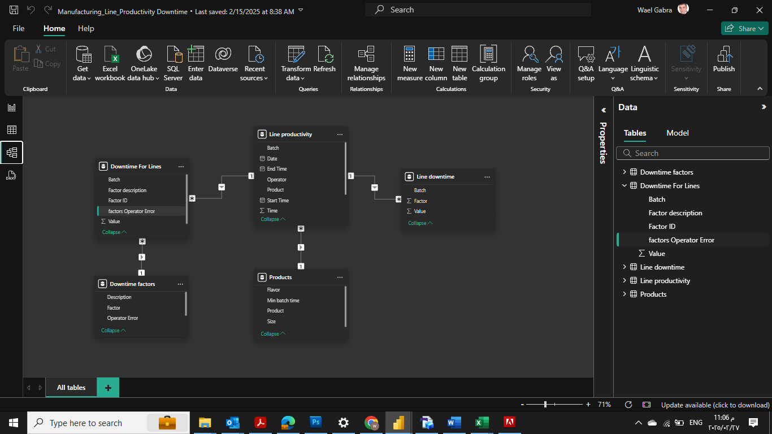

**Analysis Tools**

**The following tools were used in the analysis:**

* **Power Query: Data transformation and cleaning.**
* **DAX (Data Analysis Expressions): Custom calculations and aggregations.**
* **Power BI Visualizations: Interactive charts, tables, and dashboards.**
* **Data Relationships: Establishing connections between tables.**
* **Filters and Slicers: Enabling dynamic data exploration.**

**Visualizations**

* **Production Efficiency by Product.**
* **Downtime by Factor.**
* **Batch Time Comparison.**

**Key Questions**

* **Which products have the highest and lowest production efficiency?**
* **What are the most common downtime factors?**
* **Are operator-related downtime factors more frequent than non-operator factors?**

**Key Insights**

* **Top-performing products.**
* **Common downtime reasons.**
* **Correlation between operator errors and downtime.**

**Challenges and Solutions**

* **Data inconsistencies and missing values: Extensive data cleaning using Power Query to fill missing values and standardize formats.**
* **Establishing accurate relationships between tables: Careful data modeling with consistent keys and validation checks.**
* **Designing effective visualizations: Iterative design process with feedback loops to ensure clear and insightful charts.**

**Conclusion**

**The Power BI report provides actionable insights into production efficiency and downtime management, helping to optimize manufacturing performance.**